ROTHERHAM SAFEGUARDING ADULTS
BOARD


Safeguarding Adults

Making Safeguarding Personal
What is Safeguarding?

Mental Capacity

Sharing Information

Rotherham SAB

Prevent

Guidance and Resources

What Good Looks Like
Using Your Judgement
Abuse and Neglect
Reporting A Concern

Safeguarding means protecting an adult’s right to live in safety, free from abuse and neglect. Safeguarding involves people and organisations working together to stop abuse and neglect occurring and intervening effectively in situations if we do see abuse taking place.

When do Safeguarding Responsibilities Apply?
Safeguarding does not mean protecting every adult from every kind of harm or risk to their own personal safety. Professionals do of course have a general duty of care to the people they work with, particularly people who may be marginalised, vulnerable or at risk in some way, however the Care Act tells us that statutory safeguarding responsibilities only apply in specific circumstances. These are where an adult:
- Has needs for care and support (whether or not these needs are being met); and
- Is experiencing, or at risk of, abuse or neglect; and
- As a result of those care and support needs is unable to protect themselves from either the risk of, or the experience of abuse or neglect.

What does ‘Care and Support Needs’ mean?
‘Care and Support Needs’ means the mixture of practical, financial, and emotional support for adults who need extra help to manage their lives and be independent. For example, people with care and support needs might be elderly and frail due to ill health, disability, or cognitive impairment; have a learning disability; have mental health needs, including dementia or personality disorder; have a long-term illness/condition; misuse substances or alcohol.

Who is responsible for safeguarding?
We all are. Safeguarding is ‘Everybody’s Business’. The Care Act 2014 places adult safeguarding on a statutory footing and the law now tells us very clearly that we have a statutory duty to co-operate, to work together and to share information in order to deliver our safeguarding responsibilities. Every practitioner has a part to play in this. Always ask yourself what I have done in any situation you are involved in relating to Safeguarding.

What is Abuse?
Abuse is a violation of one person’s human or civil rights by another. There are lots of different ways that human beings can abuse or harm one another. The guidance to the Care Act gives us some examples:

Physical abuse
Such as rough handling, unreasonable restraint, hitting, burning, pushing, or kicking someone, locking someone in a room.

Sexual abuse
Such as inappropriate touching or forcing someone to take part in or witness any sexual act against their will.

Psychological / Emotional abuse
Such as intimidation, bullying, shouting, swearing, taunting, threatening, or humiliating someone.

Financial abuse
Such as theft, fraud, coercion over wills, misusing someone’s money, property, or other belongings without their agreement.

Discriminatory abuse
Such as ill-treatment or harassment based on a person’s age, sex, sexuality, disability, religious beliefs, or ethnic group.

Institutional abuse
Through rigid regimes, systemic poor care, poor organisational
culture, lack of resources, denial of choice, lack of dignity and respect for service users.

Modern slavery
Such as slavery, human trafficking, forced labour and domestic servitude

Domestic violence
Including psychological, physical, sexual, financial, emotional abuse; so, called ‘honour’ based violence

Neglect
Such as failing to provide necessary food, heating, equipment, care or medicine.

Self-neglect
This can cover a wide range of behaviour, including hoarding, failing to attend to personal care needs, failing to maintain property in a safe condition.

Why does abuse occur?
The are lots of factors and reasons behind why abuse occurs. Abuse is not always an intentional or a deliberate attempt to cause harm. It can arise out of stress, insufficient resources or lack of knowledge and skills. But abuse is often perpetrated in circumstances where one person (or persons) has
power or control over another individual.

Who can be responsible for abuse occurring?
It can be anyone. However, the person responsible for the abuse is very often well known to the person being abused. It could be a spouse; partner; son; daughter; relative; friend; carer or neighbour; a paid carer or volunteer; a health worker; a social care worker; another resident or service user; a visitor or someone who is providing a service to the person.

Where does abuse take place?
Abuse can take place anywhere: in a person’s own home, in day or residential centers, in supported housing, educational establishments, nursing homes, clinics and hospitals. It can occur on public transport, on the street or in other public spaces.

When does ‘poor care’ become ‘neglect’?
There is no simple answer to this. But the Care Act Guidance makes clear that, in regulated settings at least, there are usually options other than safeguarding for dealing with quality-of-care issues. However, one-off incidents can be serious enough for action to be taken and frequency of harmful behaviour matters. It is important to check every behaviour against the Rotherham threshold criteria.

Helping people to make their own decisions about the way they live and the care they receive is fundamental good practice. People want control over their own lives and what happens to them. Our approach to safeguarding should be no different; safeguarding should not be a process we apply to people, but instead has to be something we do with them, on their own terms. This means any adult with care and support needs should be in a position to confidently say:

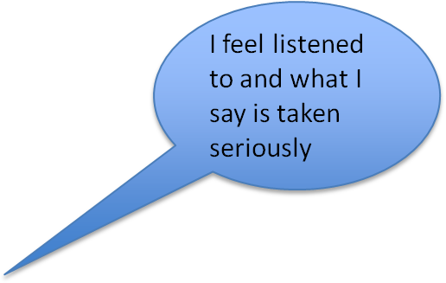
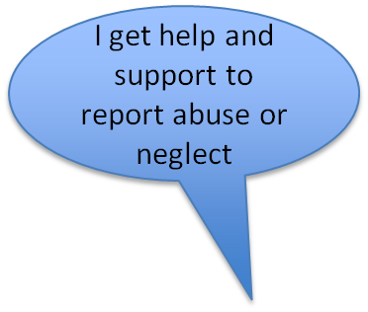

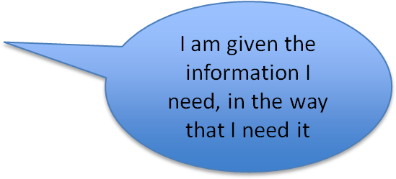
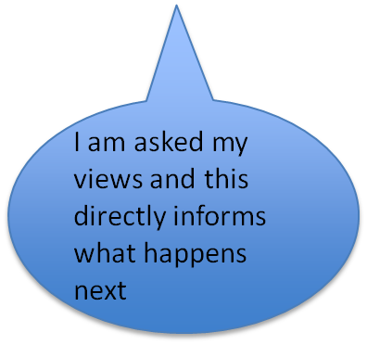
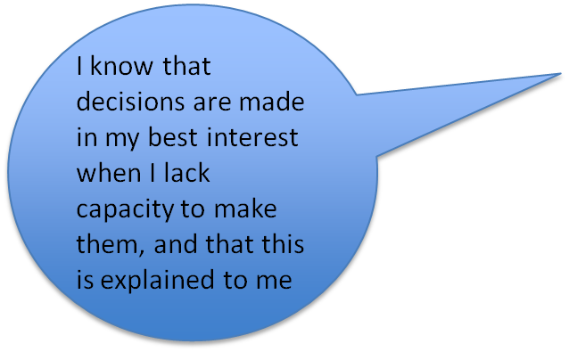
“No decision about me
without me”

If you are worried that abuse or neglect may be occurring, you can raise the matter with the local authority as a safeguarding concern. But always stop, think, and make a judgement about whether this is the best and most appropriate way to deal with the situation - there may be other options.
Wherever possible, talk to the person about what they want to happen. Their opinion should always inform your actions, although you may still have a duty of care to act in some way, even against their wishes.
Rotherham Safeguarding Adults Board wants to empower
practitioners in the town to use their professional judgement to make defensible decisions about how they practice. Reporting things to the local authority as ‘Safeguarding’ is not the answer to every concern, and other options and pathways may be open both to you and to the person with care and
support needs.

Things to consider:

- What does the person themselves want? Have you asked them?
- Do they have the mental capacity to make their own choice about it?
- Are they being coerced, pressured, or influenced by others?
- Is there anyone else involved in the care package? Do you need to have a discussion with them, tell them what is happening?
- What other options are available to you? Can you support the person to make a complaint? Raise it as a quality issue? Organise a care review? Get another agency involved?
- How serious is the level of risk? Is anyone else at risk? Do you have a duty to act, even if the person themselves does not want you to?
- Is this situation one you feel comfortable addressing yourself, or within your own team or service? Or is it beyond your level of skills, knowledge, and training?
- Who can you go to for advice and support? Have you got someone within your own organisation you can talk to about it?



SEE IT
Recognise what you are seeing or hearing may be potentially abusive or neglectful.

TALK TO THE PERSON
Make safeguarding personal: share your concerns with the person. Ask them what they want to happen.
MAKE A JUDGEMENT
Consider what the person wants. Consider their mental capacity. Consider level of risk. Consider who else may need to be informed. What options are open to you?
Do you need to take advice?



either or
REPORT YOUR CONCERN TO THE
LOCAL AUTHORITY
Go to https://www.rsab.org.uk/ For details on how to do this
TAKE ALTERNATIVE ACTIONS
Record what you have done, and why. RSAB fully supports defensible decision making by partner agencies

There are case scenarios available at https://www.rsab.org.uk/ which may help you when considering your options.

In an emergency ring 999. If you think a crime has been committed and there is no immediate risk, call the police on 101.

What is Professional Curiosity?
Professional curiosity is where a practitioner seeks to explore and understand what is happening in someone’s life, rather than making assumptions or accepting what they are told at face value. It involves looking out for signs that things are not right and seeking out the evidence of what is really happening.

Professional Curiosity is a core responsibility of all practitioners. Many people are unable, or feel unable, to speak up for themselves. Many people are relying on us to identify the signs, to uncover what is really happening in their life, and to provide them with help to be safe. This is why it is so important.

Look, Listen, Ask, Checkout!
As practitioners, ask yourself these questions to help you think in a professionally curious way:

LOOK
- Is there anything about what you see that makes you feel uneasy?
- Could what you see be a sign or symptom of abuse, neglect, or self-neglect?
- Consider why someone is behaving in a certain way
- Does what you see match with what you are being told?
- Be aware of people’s responses to questions and read body language
- Are they seeming reluctant to answer the question, is something being held back?

LISTEN
- Does something not sound right?
- Are you being told anything which needs further explanation?
- Have you spoken to the person that you are concerned about? Are they free to give their views?
- Does what you hear, match with what you have seen?

ASK
- Are there questions you can ask, to explore what you have seen or been told?
- Maintain an open mind – Try to avoid making assumptions, taking information at face value
- Is your use of language, clear, accessible, understandable to the person you are talking to?

CHECKOUT
- Treat what people say with ‘respectful uncertainty’ Take what people say seriously but look for other information that confirms or challenges what you have been told.
- Be the first to check out your concerns, be proactive, don’t wait for others to ask you.
- Are other professionals involved? Are there family members you could speak to?
- Refer to your organisations policy and procedures
- Consider the need to raise a Safeguarding concern

The Care Act 2014 has six safeguarding principles to work to as practitioners: Empowerment, Prevention, Protection,
Proportionality, Partnership, and Accountability.

If you work in line with these six principles, and if you ‘Make Safeguarding Personal’, as a practitioner you should then be able to say:




If I am concerned about something, I talk to the person I am worried about first.

I talk with the person in ways they understand, and I avoid jargon.

I support the person to set the outcomes they want – it is their life.

I keep checking that the person is happy with the way things are going.

I know how to assess someone’s decision making capacity.

I always act in the person’s best interests if they lack capacity


I know where to go to for advice if I am unsure about something
I share information when I need to
I think about the needs of carers

I work collaboratively with partner agencies

I keep people up to date with what is happening

I know how to raise a concern with the local authority if I need to

I consider the risks in any situation carefully.

My actions are proportionate - I don’t use a sledgehammer to crack a nut

Initial screening
When concerns are passed on to the local authority, it must first decide whether or not the criteria for making a formal section 42 safeguarding enquiry under the Care Act have been met. To make this judgment the local authority will normally gather information from the referrer, liaise with partner agencies who may know something about the situation, and talk to the person at the centre of the concern to find out their views. The local authority will then decide what is the best way to respond to the situation.

Section 42 Enquiries
Where the local authority has reasonable cause to suspect that the criteria is met and the person is at risk of abuse, a section 42 enquiry will be undertaken. The purpose of the enquiry is to find out whether any action should be taken, and if so what, and by whom. Remember, the focus is firmly on meeting the outcome the person wants, on their own terms: ‘No decision about me without me’. The local authority may either undertake the enquiry itself, or it may cause another agency or individual to undertake it if they are best placed to do so. Partner agencies have a legal duty to
co-operate with statutory safeguarding enquiries.

What do enquiries look like?
Enquiries are a statutory but flexible process. An enquiry could therefore range from a conversation with the individual to a much more formal multi- agency arrangement. The six safeguarding principles apply to any safeguarding enquiry, and proportionality is a key factor in deciding on the most appropriate approach. However normally the cycle consists of:
- Planning the enquiry (i.e., establishing terms of reference and who is doing what)
- Undertaking the enquiry
- Evaluating and protecting (i.e., considering what, if anything, needs to be done, by who, and who needs to know)

Advocacy
Where the person at the centre of the concerns has substantial difficulty in participating in the enquiry, the local authority will identify a suitable advocate to assist them. Where necessary, this will be via a paid independent advocacy service.

What is Mental Capacity?
‘Mental Capacity’ means a person’s ability to make a particular decision or choice for themselves. The starting point is always that adults have capacity to make their own decisions and choices in life. However sometimes a disorder in mental functioning can mean that a person’s decision-making capacity becomes impaired - for example when someone develops dementia, or when they are under the influence of alcohol or substances.

There are two established types of capacity – the functional capacity to make a particular decision and executive capacity which is the ability to carry out the decision. Therefore, someone may have the capacity to decide on a particular course of action but need someone else to carry it out on their behalf. There is an important distinction between decisional capacity, when considering the decision in the abstract, intellectually, and the executive capacity to execute or act on the decision in the real world at the material time the decision needs to be made.

What does this mean for safeguarding?
Making Safeguarding Personal means ‘No decision about me without me’. This means working with the person on their own terms, rather than simply deciding what you think is best for them. However, if the person
does not have the capacity to make a decision for themselves, then you as a practitioner may have to make that decision for them. You then have to act in their ‘best interests’. This includes deciding how to respond if you have a concern about abuse or neglect.

What does ‘best interests’ mean?
Best interests are a holistic concept. It means considering the past and present beliefs, wishes and values of the person, the opinions of others, and balancing risk against quality of life. It is important to note that best interests are NOT the same thing as always taking the safest and most risk averse option. A Court of Protection judge once said ‘What use is keeping a person safe, if it merely serves to make them miserable’?

The Mental Capacity Act
The Mental Capacity Act is the statutory framework we use for assessing capacity and for acting in the best interests of people who may lack capacity. This area is a key responsibility every practitioner working with people who have care and support needs. Your organisation should provide guidance support and training to you in how to apply the Act. Links to online guidance are also included in this booklet. If you are unsure about your practice in this area: ASK!

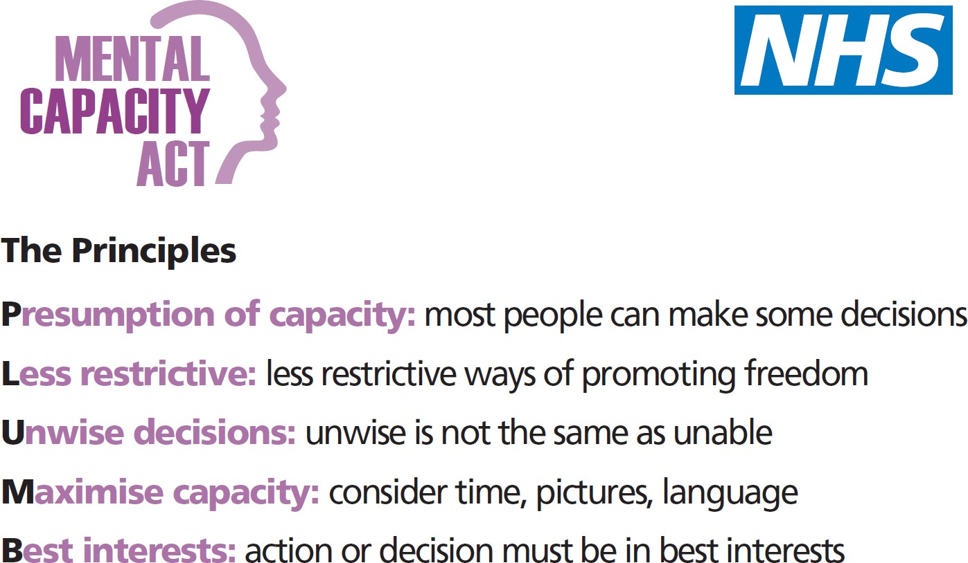
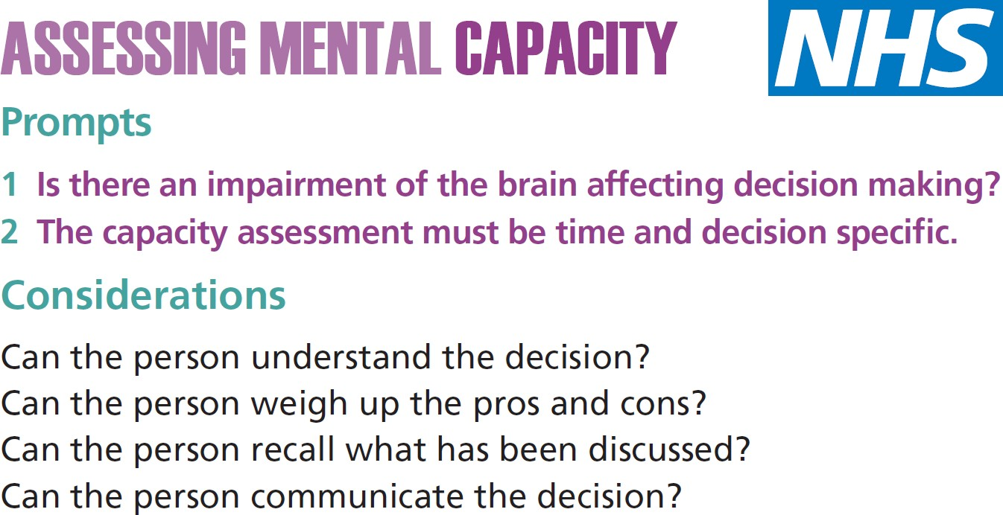

Sharing information is essential to safeguard adults with who may be at risk of abuse or neglect. In serious cases across the country, failure to share information has often been identified as a significant contributory factor when things have gone wrong. Remember that the duty to share information can be as important as the duty to protect confidentiality.
Health and social care professionals should therefore have the confidence to share information in the best interests of the people they support, within their own organisational policy guidelines and local protocols.

Consent
Information should always be shared with consent wherever possible, but a person’s right to confidentiality is not absolute - it may be overridden where there is evidence that sharing information is necessary in the public interest, is required by law, is necessary to protect personal safety, or where there are other legal reasons to do so. In some instances, the individual will not have the capacity to consent to disclosure of personal information relating to them. Where this is the case any disclosure of information needs to be considered against the conditions set out in the Data Protection Act and must be in their Best Interests as per the Mental Capacity Act.

Information sharing protocols.
Decisions about what information is shared and with whom should be taken on a case-by-case basis. But whether or not information is shared, with or without the adult’s consent, the information should be:

- necessary for the purpose for which it is being shared
- shared only with those who have a need for it
- accurate and up to date
- shared in a timely fashion
- shared accurately
- shared securely.

The local information sharing protocol for Safeguarding Adults can be found at the Rotherham Safeguarding Adults Board website.

What is the Safeguarding Board?
Adult safeguarding boards are a requirement of the Care Act, and each area must have one. Boards are formed by representatives from the local authority, local Integrated Care Boards (ICB), and the Police. The role of each safeguarding board is to oversee and co-ordinate the way safeguarding responsibilities are delivered locally. To this end, each board must produce a strategic plan, publish an annual report, and arrange for Safeguarding Adult Reviews (SARs) to be undertaken when required. Rotherham Safeguarding Adults Board (RSAB) carries out this statutory function for Rotherham. You can find further details on the board website, along with a range of downloadable safeguarding resources and publications.

https://www.rsab.org.uk/

Partner Agencies
RSAB is supported in its work by a wide range of partner agencies, all of whom have committed to working together in order to minimise the risk of abuse occurring in Rotherham, and to take effective steps to intervene if it does. You can find a list of partner agencies who have signed a ‘memorandum of understanding’ with the board on the board website.

Rotherham’s Safeguarding Adults Vision
The vision of Rotherham’ Safeguarding Adults Board (RSAB) is as follows:

“People with care and support needs in Rotherham are able to live their lives free from harm because we have a town that does not tolerate abuse; the community works together to prevent abuse and people know what to do when abuse happens”

What is Prevent?
Prevent is part of the government’s counter-terrorism strategy. It aims to reduce the risk of vulnerable people being exploited by radicalisers and subsequently drawn into terrorist related activity. Prevent is not about criminalising people – it is about reducing the risk of that happening by intervening early.

Statutory Duties
The Counter-Terrorism and Security Act 2015 contains a duty on specified authorities to have due regard to the need to prevent people from being drawn into terrorism. You care find out more here:

https://www.gov.uk/government/publications/prevent-duty-guidance

Health and social care workers have a key role in delivering the Prevent agenda. On daily basis they meet and treat individuals who may be open to exploitation by radicalisers. The key challenge is to ensure that staff can identify signs that someone is potentially being drawn into terrorism, are aware of the support that is available, and are then confident in referring the person for on for further support.

How does Prevent work?
Prevent works in the same broad way as safeguarding does: by recognising vulnerability, flagging up concerns, and then supporting the person through effective multi-agency working. If you have concerns that an individual is at risk of radicalisation, you should raise these concerns with your organisational Prevent lead or safeguarding lead. Referrals may then go to a multi-agency panel called Channel for consideration and response. Channel is a confidential, voluntary, multi-agency programme to Safeguard people identified as vulnerable to being drawn into terrorism. It provides early intervention to protect those vulnerable who might be susceptible to being radicalised. Anyone can make a referral using usual Safeguarding pathways or by contacting the local police.

WRAP (Working to Raise Awareness of Prevent)
In conjunction with the Home Office, the Department of Health has developed a training package aimed at raising awareness of this challenge. You should contact your organisation's Prevent lead for further information.

There are numerous local and national online resources available to support both individual safeguarding practice and the development of effective safeguarding arrangements within organisations:

Rotherham Safeguarding Adults Board: https://www.rsab.org.uk/

The Care Act 2014: http://www.legislation.gov.uk/ukpga/2014/23/contents/enacted

The Care Act 2014 Statutory Guidance: https://www.gov.uk/guidance/care-and-support-statutory-guidance

NHS safeguarding accountability and assurance framework: http://www.england.nhs.uk/wp-content/uploads/2015/07/safeguarding- accountability-assurance-framework.pdf

SCIE Adult Safeguarding practice questions: http://www.scie.org.uk/care-act-2014/safeguarding-adults/adult- safeguarding-practice-questions/

SCIE Mental Capacity Act resource: http://www.scie.org.uk/publications/ataglance/ataglance05.asp

Adult Safeguarding and Domestic Abuse: http://www.local.gov.uk/c/document_library/get_file?uuid=5928377b-8eb3- 4518-84ac-61ea6e19a026&groupId=10180

Safer Rotherham Partnership
https://www.saferrotherham.org.uk/

Rotherham Safeguarding Children’s Board:
https://www.rscp.org.uk/

Persons in a Position of Trust (PIPOT)
https://shorturl.at/lANX2

For further information on adult safeguarding and full policy guidance go to:

https://www.rsab.org.uk/

My organisational safeguarding lead is:

