
Text ‘EYUP’ to 85258:
Your marketing toolkit to help promote your Shout keyword

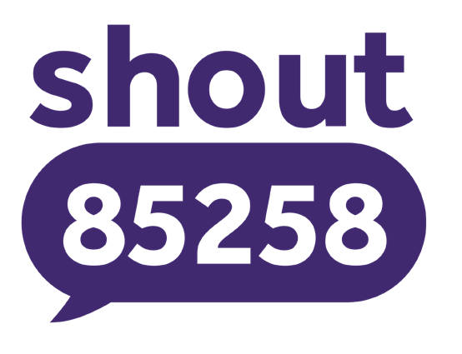


Introduction to marketing
your partnership with Shout
We’re thrilled that you’ve chosen to partner with us to help your audiences access our free, confidential, 24/7 text messaging support, provided by qualified mental health professionals.
56%
of Shout texters didn’t have anyone else to talk to
54%
felt more comfortable texting than talking about their problems
To maximise the impact of our partnership, we advise you to:

- Regularly promote your keyword through patient-facing channels such as 111 option 2, waiting rooms, websites and social media
- Share this toolkit with key stakeholders and partners across South Yorkshire services who can help you reach those who might need our support


Your next steps
Signpost to your Shout keyword service in these key places to help increase your usage:

  - 111 Option 2
Adding the service here gives people the choice to text
rather than talk out loud about their problems
  - Mental Health Services and Information
Listing the service here makes it possible for people
looking for support online to find it. This link is also included on your digital flyer.
We’d also advise adding to your local mental health pages:
    - Barnsley Mental Health Services
    - Doncaster Mental Health Services
    - Rotherham Mental Health Services
    - Sheffield Mental Health Services
  - Your Health and Services
Signposting where people are looking for the range
of support ensures they can access the service when they need it.

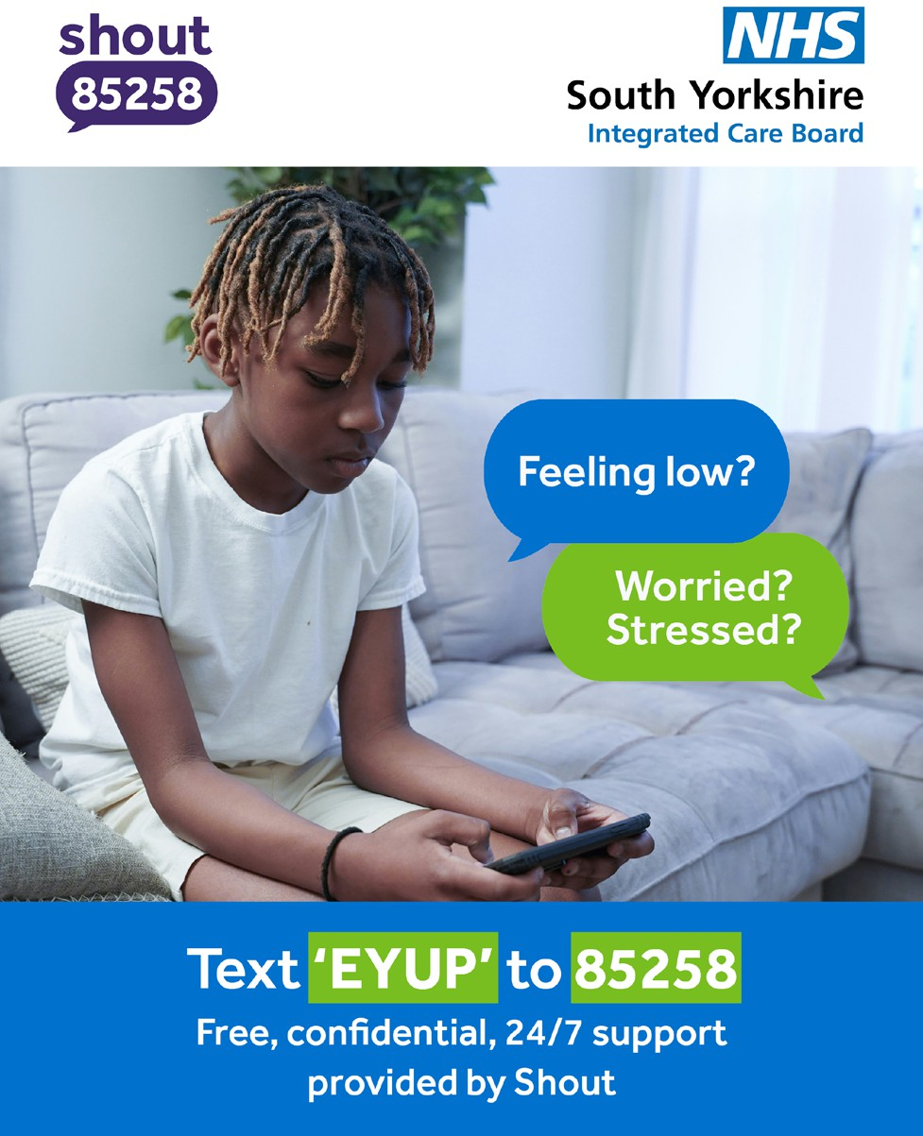
Marketing assets
Use the following assets to promote your keyword service.

Social media assets
For use across social media channels.
Download here >

Web banner
Artwork to promote your keyword on your
website and intranet.
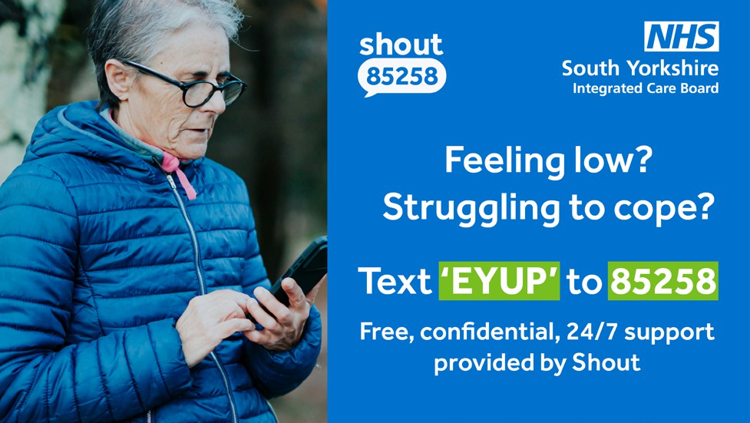
Download here >

Screen asset
To be shown on TV screens in pharmacies
and GP surgeries.
Download here >

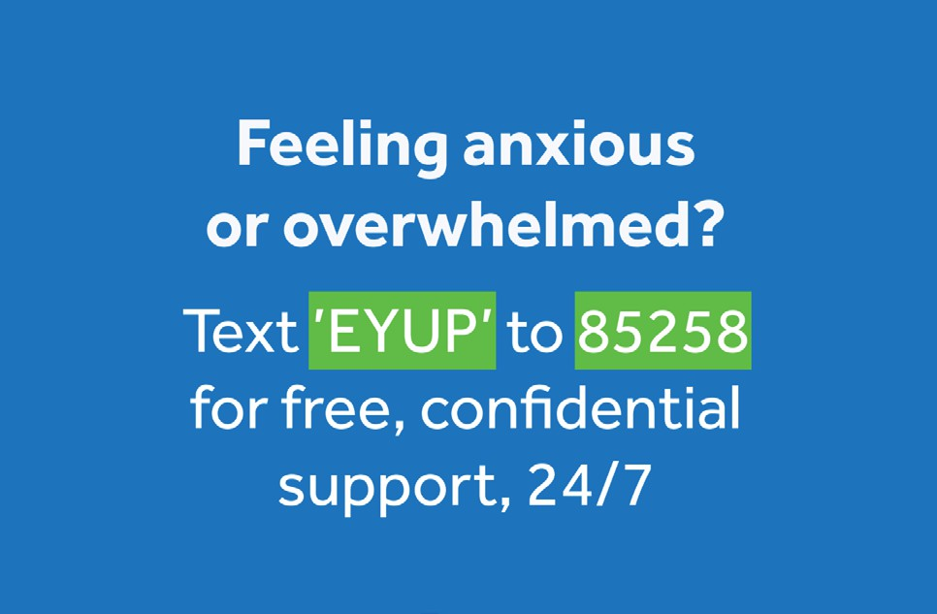
Information card
Artwork for a business card-sized asset
providing discreet information.
Download here >

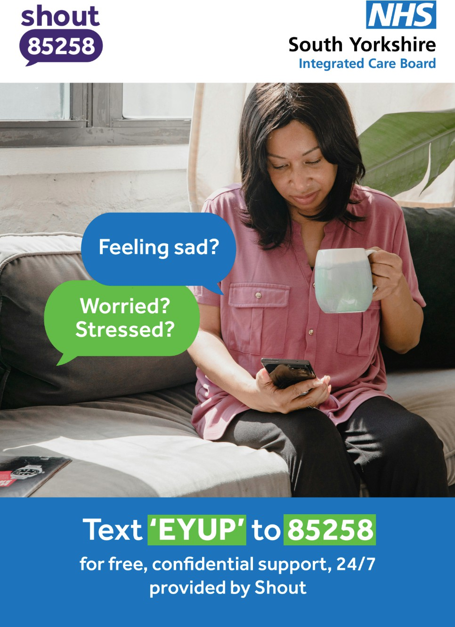
Posters
Artwork for a set of A4 posters promoting
your keyword.
Download here >

Flyers
Artwork for A5 flyers with more in-depth
information.

Download > Digital | Print
Remember to add Shout to your list of services here. This page is linked on your digital flyer.


Suggested copy

Tailor the following copy to suit your audiences, considering specific mental health struggles such as anxiety, bullying, loneliness, stress or suicide.

When writing about the service, please:

- Always state that it’s provided in partnership with Shout. This helps people to understand who they’re texting when they send a message to 85258

- You may want to include that the Shout service is powered by Mental Health Innovations, registered charity number 1175670

Suggested copy:
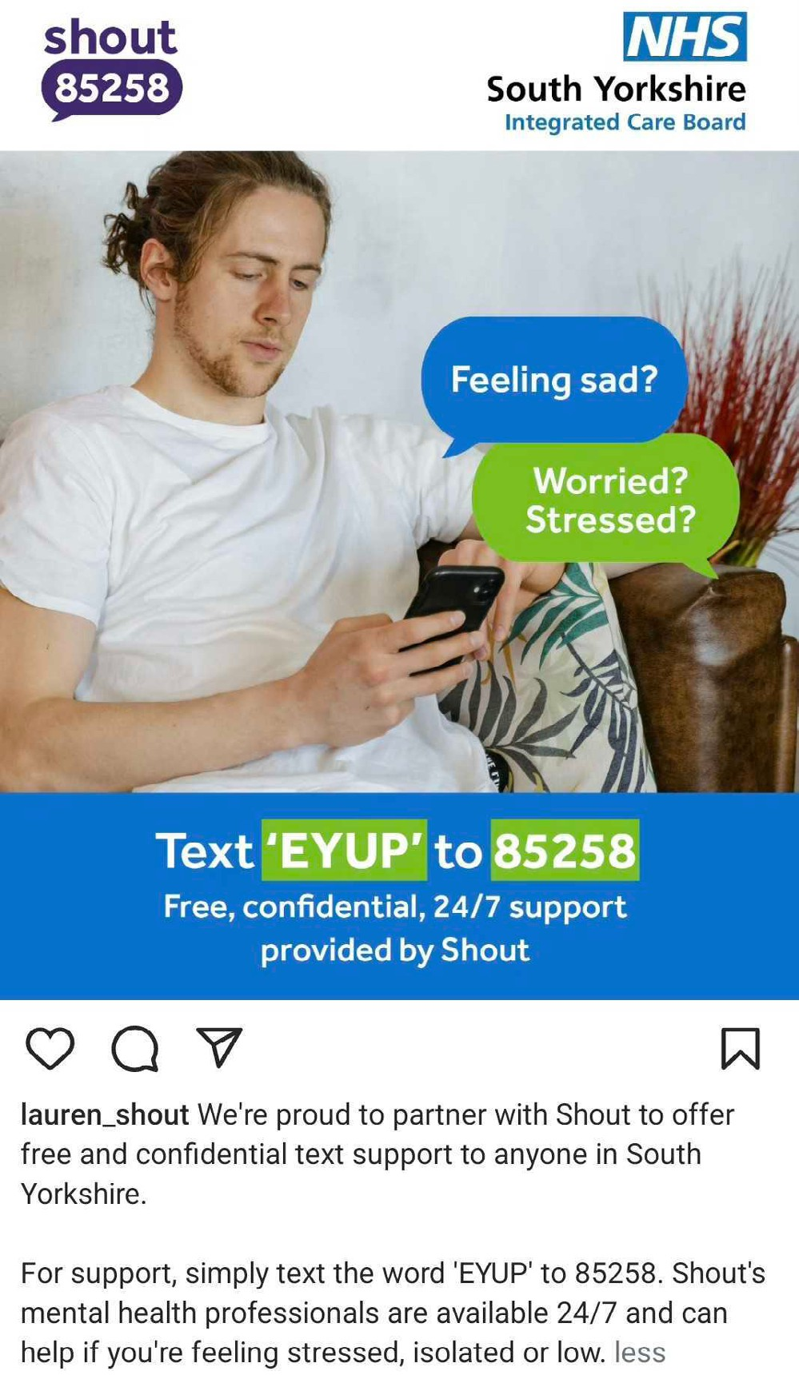
About the partnership

Example 1: We’re proud to partner with Shout to offer free and confidential text support to anyone in South Yorkshire.
For support, simply text the word ‘EYUP’ to 85258. Shout’s mental health professionals are
available 24/7 and can help if you’re feeling stressed, isolated or low.

Example 2: Are you feeling anxious or overwhelmed? Talk silently and anonymously to a mental health professional by texting the word ‘EYUP’ to 85258.
We’re pleased to be working with Shout to offer free, confidential support by text message, 24/7.

Suggested copy:
Promoting your keyword

Example 1: Feeling sad or anxious? Text ‘EYUP’ to 85258 for free, confidential text support, provided by Shout

Example 2: Feeling isolated or low? Text ‘EYUP’ to 85258. Our partner Shout is here to listen, 24/7

Example 3: Struggling with unwanted thoughts? You’re not alone. Text ‘EYUP’ to 85258 for free, confidential mental health support by text message, provided by Shout

Example 4: Need to talk? Text ‘EYUP’ to 85258
to connect with Shout for a text conversation that’s free, confidential and available 24/7

Tag Shout
on social media:

LinkedIn: Shout UK and Mental Health Innovations

Twitter: @GiveUsAShout

Instagram:
/giveusashoutinsta

Facebook:
/giveusashoutuk

TikTok: @giveusashout



Audiences

Key stakeholders
If you haven’t already, it can be helpful to map the key teams, partners and service providers who can help you to reach your audiences.
Start planning with our stakeholder mapping tool.

PR and media
We’ve drafted a press release template for you to use when reaching out to local or industry news.

Possible texters
You’ll find suggested copy and promotional assets on the following pages of this toolkit.


Case study: Navigo
Navigo is a not-for-profit social enterprise based in North East Lincolnshire, where it supports nearly 170,000 people as an NHS integrated health, social and mental health service provider.

As a Shout keyword partner, Navigo has doubled the number of people they support with their mental health after a creative localised marketing campaign promoting their keyword.

Read in full >
“It’s really important to get the word out there about the service, to let people know
they can use it.
Use different marketing channels, tailor the messaging to your audience and work with local partners - your collective reach
is much greater.”
Anna Morgan
Director of Corporate Services, Navigo

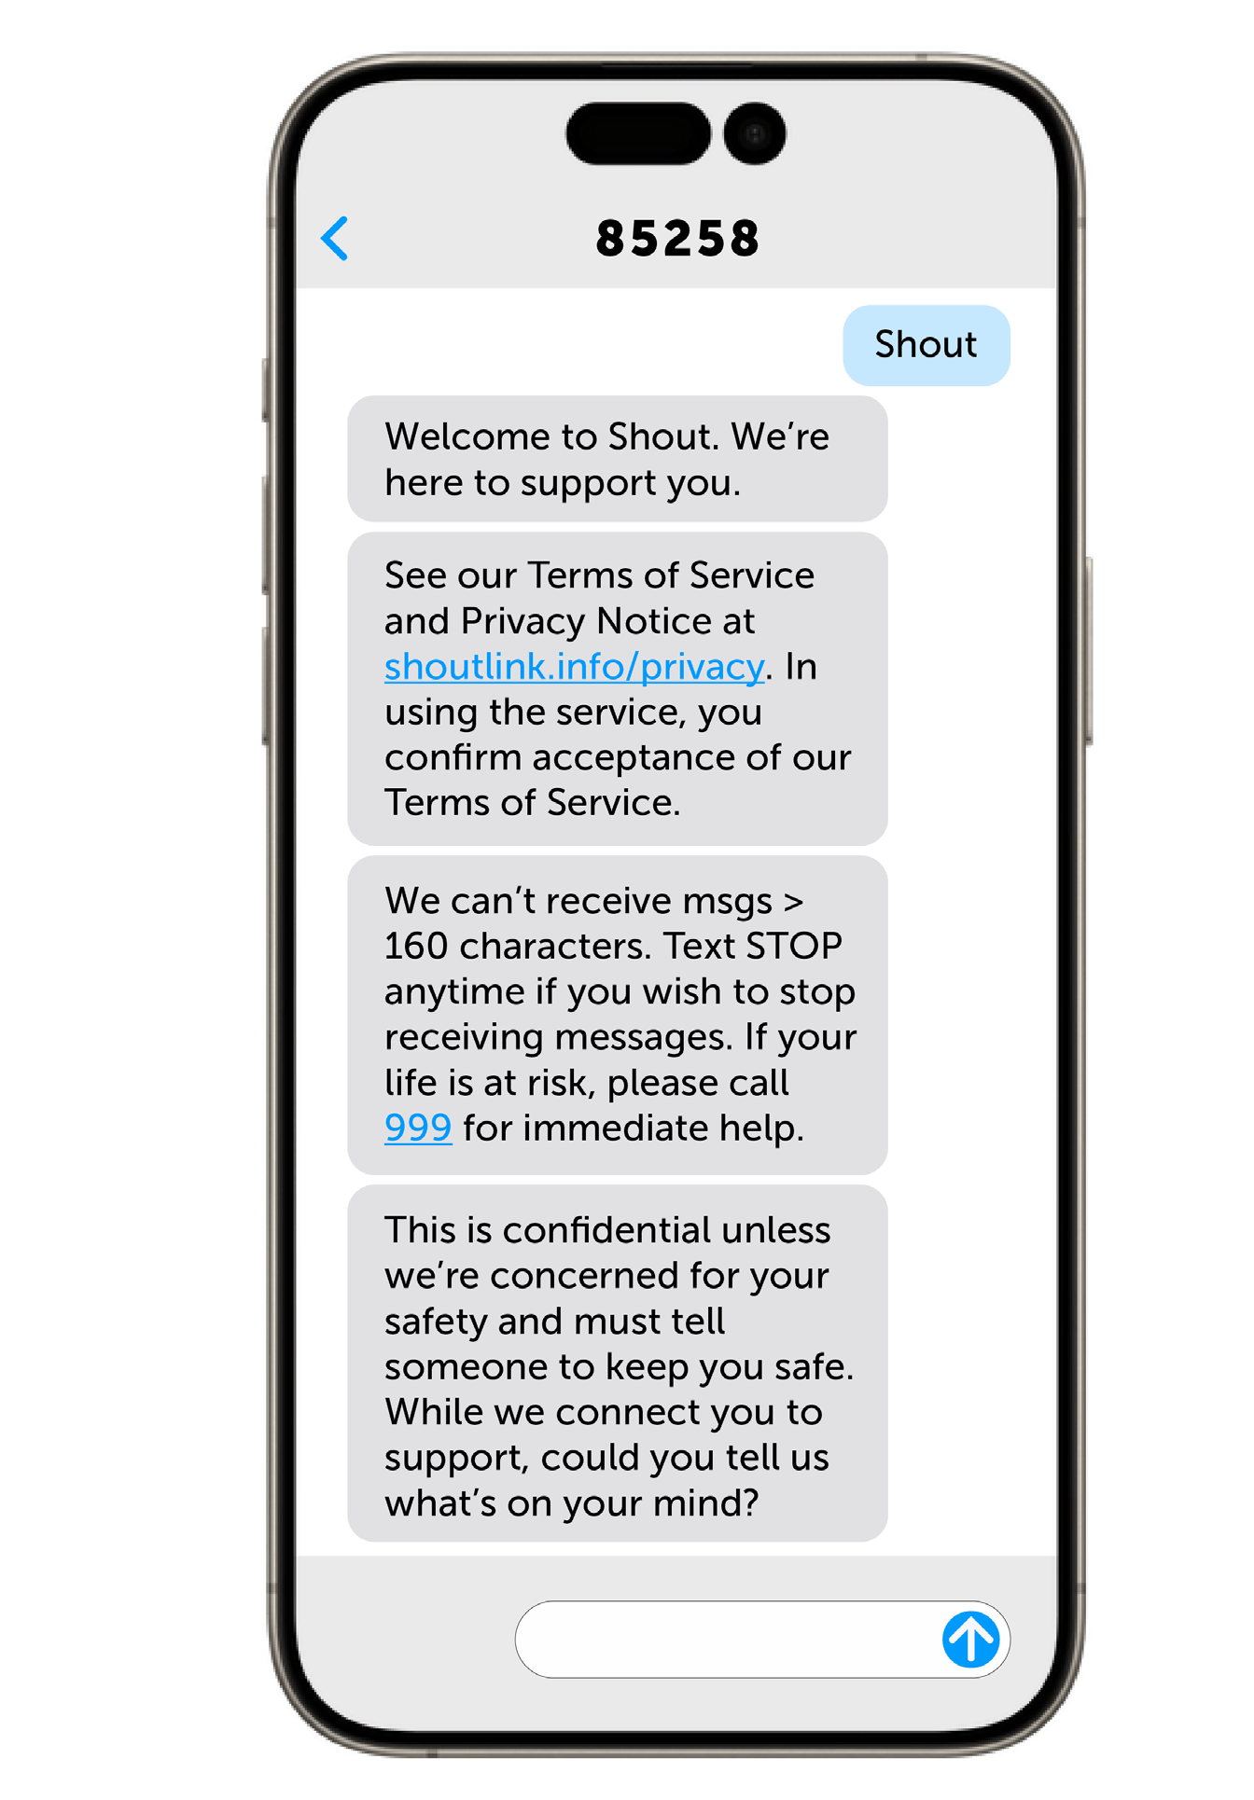
How does the service work?

EYUP
Shout is the UK’s only free, 24/7 text support service, powered by Mental Health Innovations. Its accessibility ensures support is available to those who might otherwise struggle to access help, easing pressure on face-to-face and phone services.

Conversations through Shout’s clinically-led service are taken by mental health professionals, overseen by Clinical Supervisors.

Commissioning Shout enables ICBs to deliver against NHSE advisory specifications for implementation of 24/7 crisis text message services.

Texter FAQs

Download these graphics covering the questions Shout texters most commonly ask to share with your audiences.
Especially for young readers, here’s an easy-to-read explanation of how Shout works.

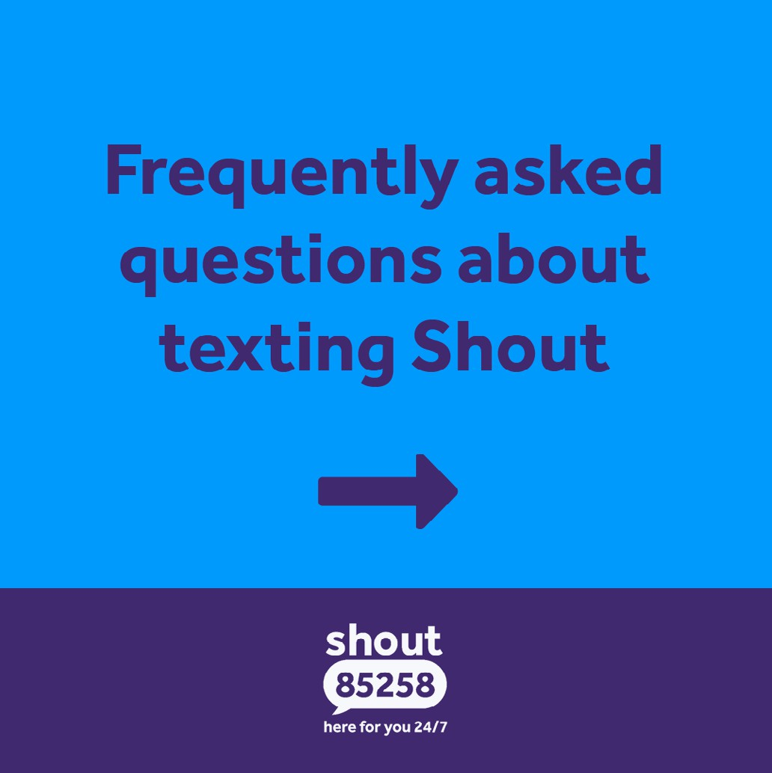
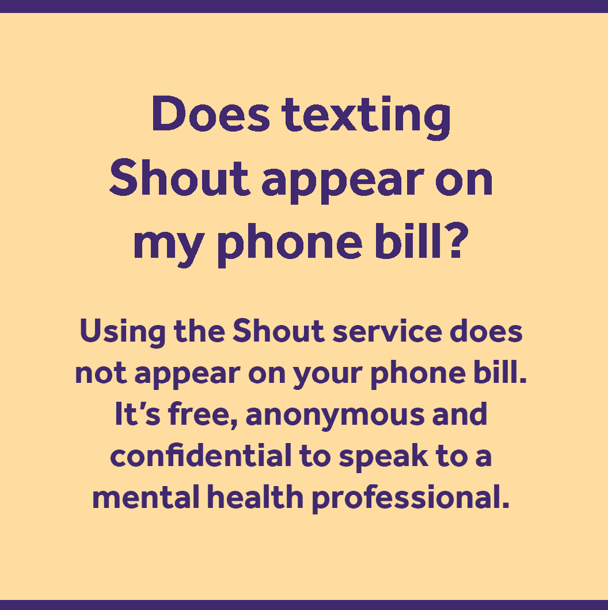
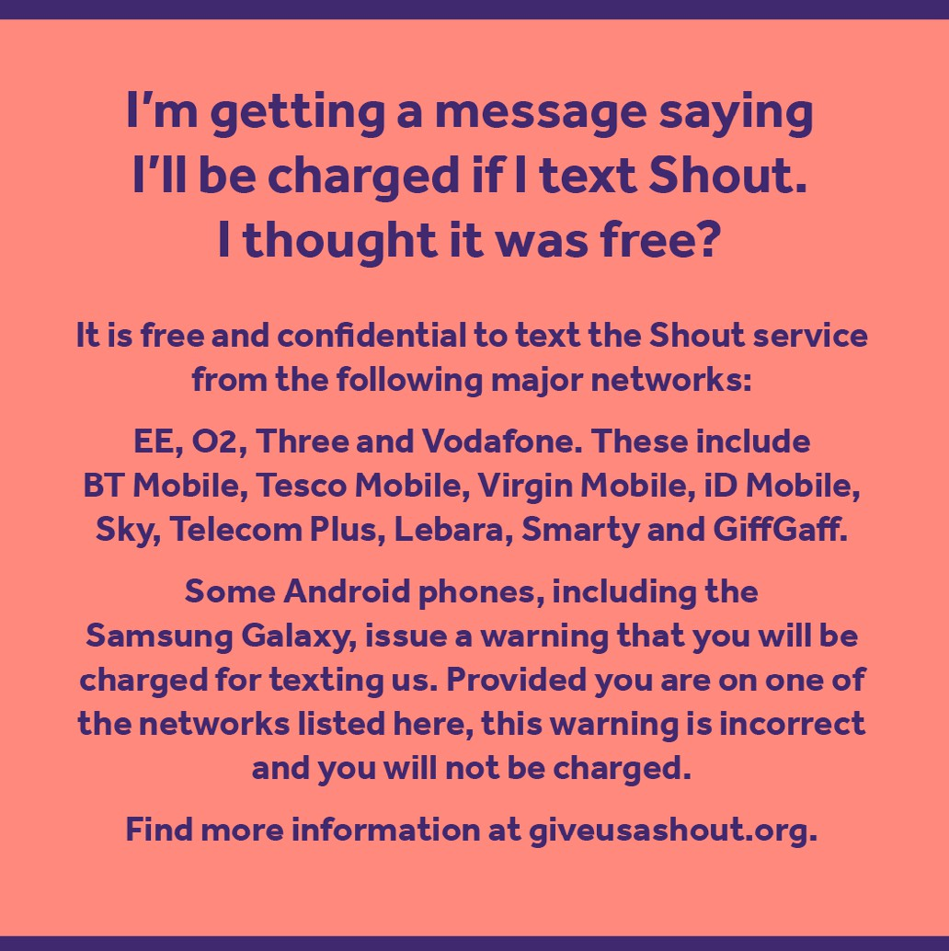


What else you can expect
from Shout in your first year

Mental health content calendar
Download your calendar of key dates in the UK.

Events
Look out for invites to quarterly clinical webinars and our annual best practice workshop for keyword partners.

Quarterly newsletter
You’re on the list for our roundup of news and insights exclusively for ICB partners.

Content toolkits
We’ll send additional assets to share with audiences at key times of year, in line with Shout campaigns.


Other support available to you and your audiences

Shout: Our website has advice and resources on a wide range of issues and situations that can impact our mental health.

The Mix: Online articles, community boards, The Mix Six podcast and more, to connect young people to information and advice from experts and their peers.

Mental Health Innovations: Our reports look into current mental health issues in the UK, exploring Shout’s unique data insights and sharing clinical expertise from our team.



More ways to get involved

Fundraising
Fundraising is a great team builder and effective way to raise awareness of our partnership. We offer a wide range of ways to fundraise, including walks,
runs, comedy nights and more. Talk to us about what your team might be interested in!
Explore fundraising opportunities >

Payroll giving
We’re partnered with GoodPAYE to allow people to donate to straight from their salary - the simplest and most efficient way to support Shout.
Find out more >


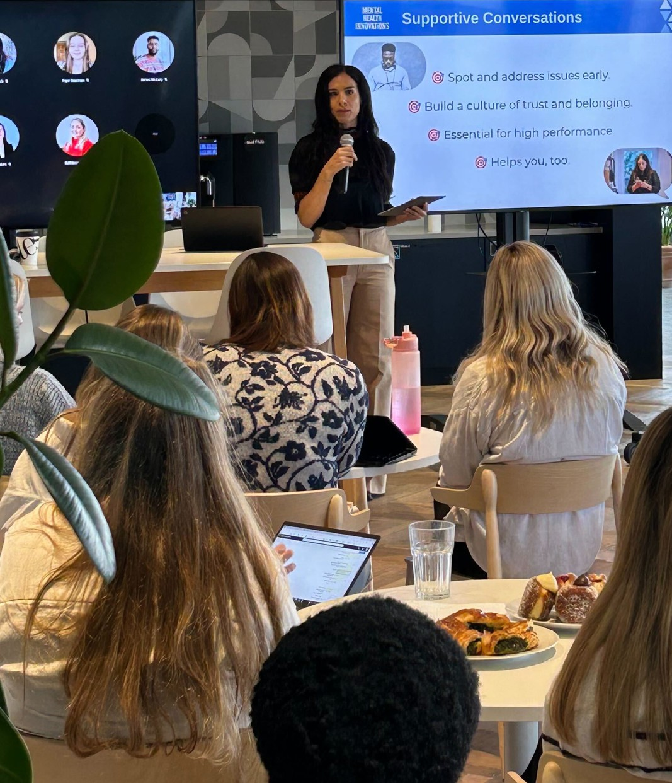
More ways to get involved

Training
We work with organisations to empower teams with the skills to hold supportive conversations and create a mentally healthy workplace.
Find out more >

Volunteering
Shout Volunteers have taken more than 2.9 million conversations with 930,000 texters in need of urgent support. We’re currently recruiting and we’d love you to join the team.
Find out more >

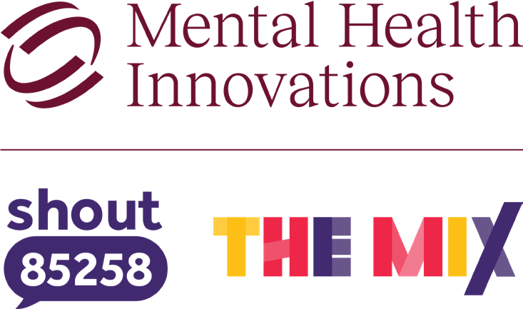
For more information, Shout’s brand guidelines
or any other support with marketing, please contact:

Emma Wilson
Senior Marketing and Partnerships Manager
emma.wilson@mhiuk.org

Registered charity number 1175670. PO Box 78319, London W10 9FE

