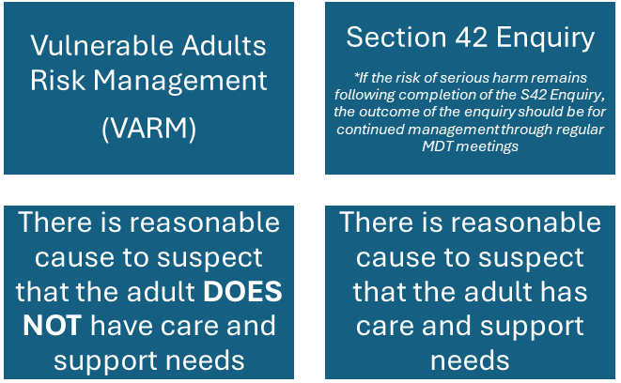

Vulnerable Adults Panel

(VAP)

Risk of serious harm

Note:

There will be instances when an adult has eligible care and support needs and presents with additional complexities, such as – substance use, mental health, historical or current exploitation. This will be considered on a case-by-case basis and a partnership decision will be made regarding whether it is more appropriate to manage the case under VARM.

Cases cannot be managed simultaneously under VARM and a Section 42 Enquiry.