**Vulnerable Adult Risk Management Model (VARMM)**

**Name of Adult:**

**Date of Birth:**

**Address:**

**Date of Meeting:**

|  |
| --- |
| **Presentation** (reason for referral, summary of current situation and risk, including risk to any children) |
| **Predisposing factors** (historical factors, vulnerabilities, what’s already there that makes risk possible?) |
| **Significant events / circumstances / triggers** (what is perpetuating the risk / maintaining the current situation?) |
| **Protective factors** (strengths, what reduces the risk?) |
| **Views of the Vulnerable Adult** |

|  |
| --- |
| **Key updates since last VARM meeting (if applicable):** |

**Risk Management Plan**

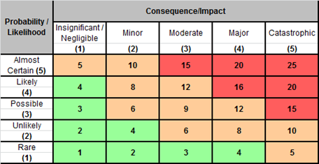

|  |  |  |  |  |
| --- | --- | --- | --- | --- |
| **Identified Risk** | **RAG score** | **Actions to Mitigate Risk** | **Action Owner** | **Completion Date** |
|  |  |  |  |  |
|  |  |  |  |  |
|  |  |  |  |  |

**Outcome**

|  |  |
| --- | --- |
| **VARM reviewing meeting** |  |
| **Step-down** (include details of lead agency below) |  |
| **Escalation to VAP** |  |

|  |
| --- |
| **Rationale for decision:** |

|  |  |
| --- | --- |
| **Next VARMM date & time (if applicable):** |  |
| **Date plan shared or discussed with the Vulnerable Adult:** |  |

**Signature of Chair:**

**Date:**