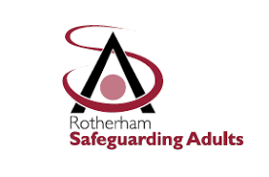**Rotherham Safeguarding Adults Board Newsletter**

**August 2025 Edition**

# **Welcome**

Welcome to the August 2025 edition of the Rotherham Safeguarding Adults Board (RSAB) newsletter. The newsletter will be published on a quarterly basis to keep the workforce across the partnership informed of developments.

The RSAB are dedicated to protecting adults with care and support needs from abuse and neglect. Our objective is clear, to ensure that local safeguarding arrangements and partnerships are effective in protecting adults at risk of or who are experiencing neglect and abuse. To achieve this, we must ensure that everyone works to safeguard vulnerable adults in our community.

If there is something you would like to see featured in any future editions, please let us know.

**Getting in touch…**

Website: [www.rsab.org.uk](https://eur02.safelinks.protection.outlook.com/?url=http%3A%2F%2Fwww.rsab.org.uk%2F&data=05%7C02%7CDanielle.Radford%40rotherham.gov.uk%7C6fb0e8e7662f40c3599b08dc348aea27%7C46fbe6fd78ae47699c1dbcea97378af6%7C0%7C0%7C638443018451708441%7CUnknown%7CTWFpbGZsb3d8eyJWIjoiMC4wLjAwMDAiLCJQIjoiV2luMzIiLCJBTiI6Ik1haWwiLCJXVCI6Mn0%3D%7C0%7C%7C%7C&sdata=0tvlSMraJUPHaTeohM%2BpPm24qHXD0c1pW%2BQTxznxdOU%3D&reserved=0)  
Email: [RSAB@rotherham.gov.uk](mailto:RSAB@rotherham.gov.uk)

# **The Foundation of the RSAB**

**Rotherham Safeguarding Adults Board Independent Chair**

Reporting to the Independent Chair is:

* Rotherham Metropolitan Borough Council (RMBC)
* South Yorkshire NHS Integrated Care Board (SYICB)
* South Yorkshire Police (SYP)

Whilst other partners include:

* The Rotherham NHS Foundation Trust (TRFT)
* Rotherham Doncaster and South Humber NHS Trust (RDaSH)
* South Yorkshire Fire and Rescue (SYF&R)
* Rotherham Probation Services
* Voluntary and Community Sector
* Rotherham Cabinet Member for Adult Social Care and Health

The RSAB has four subgroups which undertake the activity and work for the Board:

* **Performance and Quality**  
  *Joint Chairs: Head of Safeguarding (RMBC) & SNS Police Inspector (SYP)*
* **Policy and Practice**  
  *Joint Chairs: Principal Social Worker & Named Nurse for Safeguarding (TRFT)*
* **Workforce Development**   
  *Joint Chairs: Head of Safeguarding (RDaSH) & Named Nurse Safeguarding (TRFT)*
* **Safeguarding Adult Reviews (SAR)**   
  *Joint Chairs: Assistant Director AC&I (RMBC) & Head of Safeguarding (TRFT)*

# **Safeguarding Performance**

**Safeguarding Contacts, Concerns, and Progression to Enquiry**As seen in earlier reports there continues to be an increase in demand across the Safeguarding pathway. In 2024/25 there were 4,602 contacts received where Safeguarding risk was indicated. This is a 15% increase on the 3,993 received in 2023/24, and 22% more than the 3,713 in 2022/23. The monthly average for the year was 383.5 compared to 329.8 in the previous year. 43.2% (1,987) were accepted as Safeguarding Concerns and were subject to initial enquiries. A slight increase in acceptance rate of 0.7% compared to 42.5% last year. Of these 1,987 Concerns 40.4% (802) progressed to an Enquiry, an increased position on last year’s 35.4%. The remaining 1,185 (59.6%) closed following initial investigation by using a case management or other similar non-statutory approach.

**Completed Enquiries**Following the quarter-on quarter increase in the number of enquiries completed in the last year, quarter 4 had the lowest level with 186 enquiries completed, (170 S42s plus 16 other) compared to 243 last quarter. A similar decline occurred in the fourth quarter of the last year suggesting there are some seasonal impacts. As predicted in earlier reports, over the 2024/25 year there were 850 enquiries completed, with 805 Section 42 and 47 Other Enquiries. This is a significant increase of 37% on last year's 535 completed enquiries.

**Abuse Categories**The top 3 abuse categories for completed enquiries received this year remain consistent. However notable increases in Neglect and Physical;

Neglect has risen in prevalence by 4.4% on last year and there is a significant gap between Neglect and the next most common categories. Other abuse types that have seen notable changes since the previous year are Organisation abuse which has increased by 3.5% to 14.4% of all enquiries, and Domestic Abuse which has reduced by 2.2% to 6.9%.

**Repeat Concerns**

The 4,602 Safeguarding ‘Contacts’ received this reporting year related to 2,921 individual adults. 889 adults had more than one SG contact which equates to 30% of individuals subject to a repeat episode within the reporting period. This is slightly higher (+1%) than the 28-29% seen in the last three years.

# **Safeguarding Partner Updates**

1. **Rotherham Metropolitan Borough Council – Adult Social Care**

**Emollient Risk**

Doncaster had a tragic incident earlier in the year with regards to a man who died in a house fire after his clothing caught fire on a gas heater due to a build-up of flammable skin cream.

This case is still with the coroner, but our SYFR have informed safeguarding boards that they have seen increased fire fatalities regionally and nationally related to emollient use and smoking/other fire risks.

SYFR has already identified it is also essential that care providers and carers receive the relevant training to understand fire risks and emollient use.

**Training 🡪** [**Emollient creams - South Yorkshire Fire and Rescue**](https://eur02.safelinks.protection.outlook.com/?url=https%3A%2F%2Fwww.syfire.gov.uk%2Fsafety-advice%2Fsafety-in-the-home%2Femollient-creams%2F&data=05%7C02%7Cjackie.scantlebury%40rotherham.gov.uk%7C2eb8f9f491b54f47075a08dda82de8c1%7C46fbe6fd78ae47699c1dbcea97378af6%7C0%7C0%7C638851637328052042%7CUnknown%7CTWFpbGZsb3d8eyJFbXB0eU1hcGkiOnRydWUsIlYiOiIwLjAuMDAwMCIsIlAiOiJXaW4zMiIsIkFOIjoiTWFpbCIsIldUIjoyfQ%3D%3D%7C0%7C%7C%7C&sdata=OrAyplWOxk7QLPZOBCFK0wLaR%2F%2F%2BuUf4O6sw6pBj%2BC4%3D&reserved=0)

**Guidance 🡪** [**https://www.gov.uk/guidance/safe-use-of-emollient-skin-creams-to-treat-dry-skin-conditions**](https://www.gov.uk/guidance/safe-use-of-emollient-skin-creams-to-treat-dry-skin-conditions)

1. 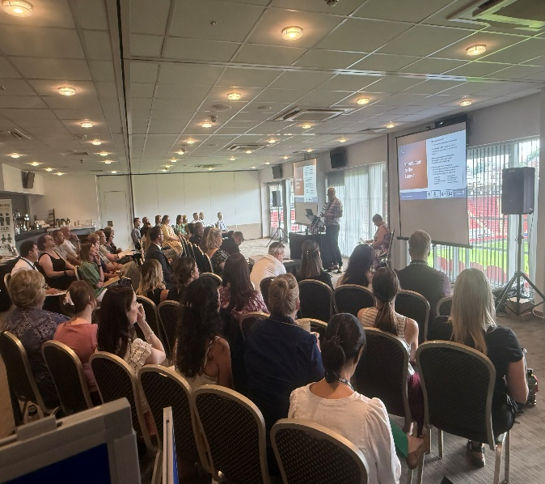**Rotherham Metropolitan Borough Council – Vulnerable Adult Pathway**

RMBC has launched its new Vulnerable Adults Pathway in conjunction with agencies from across the partnership.

The purpose of the Vulnerable Adults Pathway is to is to take a multi-agency approach to address the complex needs of identified vulnerable adults, where previous or isolated interventions have not reduced risk to an acceptable level.

The launch consisted of an in-person event at New York Stadium and two virtual sessions, which were well attended by colleagues from across the partnership. Colleagues were invited to learn about the new process, to ask questions and to share their thoughts. It was a great week or networking and learning opportunities, with the pathway becoming live on 07/07/25.

1. **The Rotherham NHS Foundation Trust (TRFT)**



* We’re proud to share that TRFT have made the final of the HSJ patient safety awards for our partnership simulation training with RMBC – wish us luck for 15 September!
* TRFT are celebrating Learning Disability Awareness Week in June 2025
* 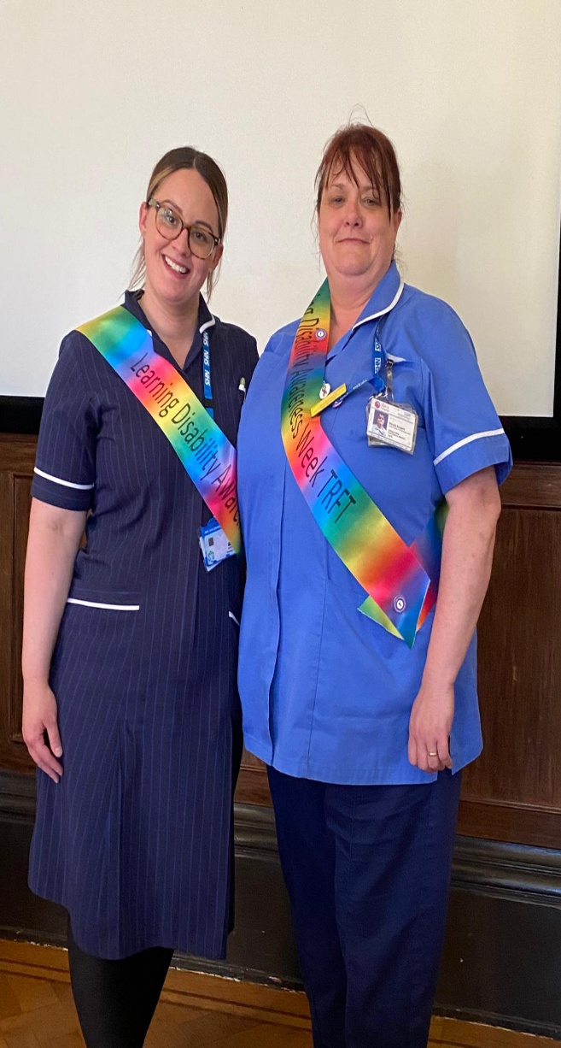Quality Improvement Focus   
  QI project on A2 to improve MCA and DoLS practice. QI work on A4 linked to Dementia Practice. QI in Emergency Department to embed mental health assessment tool following successful pilot on AMU.
* CQC feedback on inspection at another Trust, highlighted TRFT at another Trust, highlighted TRFT as exemplar practice in improving the Mental Health & Safeguarding processes. We have met with this NW Trust to share our journey.
* Working with the Rotherham Hospital and Community charity, we have been awarded £4500 to work with Bluebell Wood, providing bereavement support to families who face the unimaginable loss of a child.

1. **Rotherham, Doncaster and South Humber NHS Trust (RDaSH)**

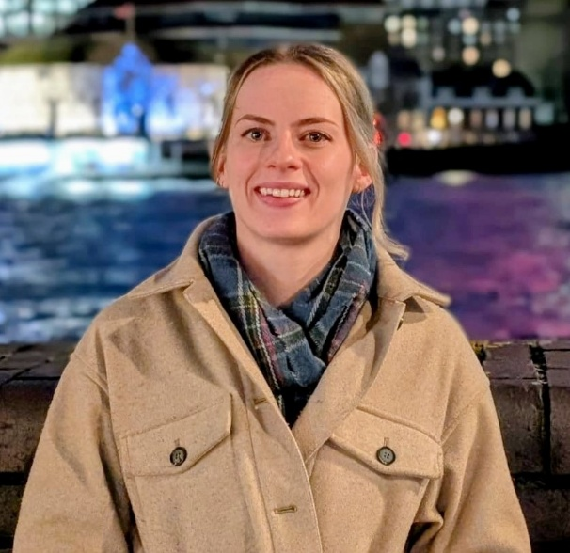Meet our dedicated Domestic Abuse and MARAC Lead Rebecca Fawcett, a vital member of our health organisation committed to safeguarding and supporting individuals and families affected by domestic abuse and from a whole family perspective. With specialist training and a compassionate approach, Rebecca works closely with, staff, and partner agencies to promote identification for signs of abuse, provide supervision support, and ensure appropriate referrals to specialist services. Their role is crucial in promoting a safe environment contributing to risk assessments and risk management at Multi agency risk assessment conferences (MARAC), raising awareness through staff training, and embedding best practices across our services. Their leadership ensures that domestic abuse is not only recognised but actively addressed, making our organisation a safer place for all fulfilling the underpinning legislation of the Domestic Abuse Act 2021.



1. **NHS South Yorkshire Integrated Care Board (SYICB)**

The ICB consultation process surrounding the organisational changes and configuration of the NHS has been delayed until the SYICB receive further guidance from NHS England.

Once the guidance has been received the consultation process will commence. We will ensure that partners and stakeholders are kept informed as plans emerge.

The Governments Fit for the Future 10-year Health Plan for England was published in July 2025 and SYICB are currently planning how in our new form as strategic commissioners this will be delivered.

We remain committed to working together with partnerships across South Yorkshire and in each place.

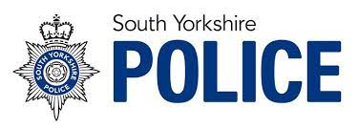

1. **South Yorkshire Police (SYP)**

Based at Riverside House and pan Rotherham policing district our aim within Safer Neighbourhood Services is to assist our colleagues across the partnership to reduce demand and create innovative ways of problem solving using the full spectrum of partnership knowledge and powers (statutory and non-statutory) to tackle crime and anti-social behaviour, safeguard the vulnerable and achieve excellent victim service.

We hope this article will assist colleagues to better understand our roles and processes and increase the working knowledge of the team can provide a better more holistic service to the communities we serve.

The SNS family tree and e mail contact details are Email:  [Rotherham_Safer_Neighbourhood_Services@southyorks.pnn.police.uk](mailto:Rotherham_Safer_Neighbourhood_Services@southyorks.pnn.police.uk)

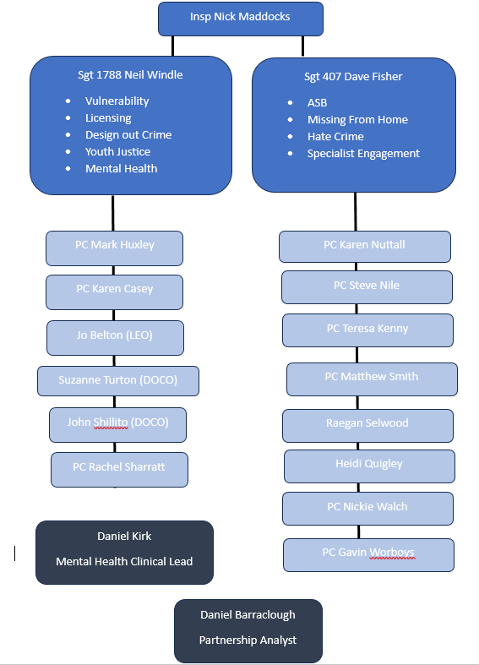Updates from this quarter as below highlight some of the work undertaken in the Missing from Home (MFH) and Vulnerability portfolios.

**MFH**  
In June, this year the team worked on a high-risk missing person case in collaboration with PVP. The individual concerned was being taken out of the country by her family after they found out she was in a relationship with another female. There were concerns for Honour Based Violence and she was sent away from Manchester airport but her whereabouts after this were unknown. She was subsequently located following collective efforts and secured for a Karna Nirvana assessment. Both MFH and PVP staff working on this case received a commendation for their efforts.

In the last 6 months the team have received 6 reports for 4 different people suffering with dementia and being reported missing. All were located within 12 hours of the initial call being made. Herbert Protocol and Dementia Tags are now in place for/provided to all concerned.

**Vulnerability**  
The vulnerability officer role within the SNS the aims ensure the relevant care and support is in place for the vulnerable adults that are identified to us. These individuals are identified to me through the VA referrals that are submitted. On average we will receive and process around five each week. However, as well as these referrals we also view the Top 10 Repeat Demands and Top 10 Vulnerability Dashboard via Police Performance Reports and identify anyone those requiring further support and contact via the relevant agencies so their care and support needs can be addressed. The Vulnerability Officer will attend regular multi- agency meetings so that the vulnerable persons need can be discussed to ensure they are receiving the relevant support. On some occasions these individuals are contacted directly either on a home visit or via telephone so that their needs can be discussed. We have previously signposted individuals to the mental health services and made several referrals to ROADs for drug and alcohol support. We have also spoken with the family members of relatives with dementia and discussed the Herbert Protocol and explained this process and sent these forms out for completion. Research is undertaken and information provided around 136 patients and repeat callers that have been highlighted. SNS deal with a number of vulnerable adults who are at risk of exploitation and often a criminal investigation is recorded alongside the VA referral. One example of this in this reporting period is regarding a male who suffers with dementia. There were concerns his family were taking money from him. The officer in the case was struggling to investigate the matter. The SNS in attending the planning meetings for this male were able to obtain details of the family members and the social workers involved, who were able to provide the evidence required. This was given to the officer and as a result the suspect was arrested and processed and the victim safeguarded.



1. **South Yorkshire Fire and Rescue (SYF&R)**

South Yorkshire Fire & Rescue (SYFR) are committed to making South Yorkshire Safer & Stronger and have a duty to promote fire safety but need your help in reaching people in the community. SYFRs prevention work has helped to reduce the number of accidental house fires. Analysis of each incident has found common factors involved in almost of all our recent fire deaths, such as hoarding, emollients, smoking, substance misuse and mental health. Many house fire victims were already known to at least one other agency but sadly not SYFR.

The best way to help SYFR, help those most at risk is to sign up to become a Safer South Yorkshire Referral Partner. The Safer South Yorkshire Referral Partnership aims to improve how the fire service and local organisations work together to effectively identify and reduce hazards for people most at risk.

SYFR believe the Safer South Yorkshire Referral scheme is a secure and convenient way for all partners to effectively make referrals for Home Fire Safety Visits.

Partnership of the scheme will enable SYFR and partners to work together to keep our communities and services safer.

This is done by:

* SYFR training partners and their teams on Fire Safety Awareness
* Secure referral pathways for partners working with people at risk
* SYFR carrying out Home Fire Safety Visits

A Home Fire Safety Visit includes specific advice on reducing fire risks, tailored escape plans, checking smoke alarms are working. SYFR also sign post to other partner agencies when a need is identified. As an active partner we attend the local multi-agency meetings where any identified risks or trends can be discussed.

If you require further information, would like to become a referral partner or you are an existing partner who would like to arrange training for your team please contact SYFRs partnership team at [safe&well@syfire.gov.uk](mailto:safe&well@syfire.gov.uk).

Safe Use of Emollients Video - [Safe use of emollients](https://www.youtube.com/watch?v=GAv7RTjDClU&t=1s)

1. **Rotherham Safeguarding Adults Board Training**

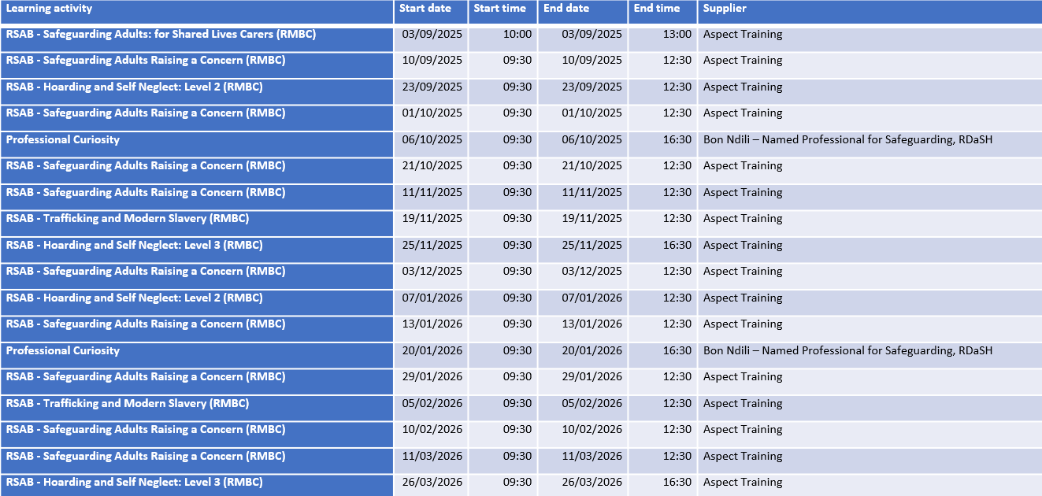**Safeguarding Adults Board Course Summary**

Rotherham Borough Council staff should book training via YourHR. Colleagues from partner agencies should book places using the booking form <https://forms.office.com/e/cP9CSpzPRs>

Please visit the below link to view the full Rotherham Safeguarding Adults Board prospectus (<https://www.rsab.org.uk/downloads/file/154/rotherham-safeguarding-adults-board-training-prospectus>)

Please refer here to book for the joint Professional Curiosity course.

[Training – Rotherham Safeguarding Children Partnership](https://www.rscp.org.uk/training)

1. **Healthwatch Rotherham**

The Impact of Having ADHD and Autism

Attention deficit hyperactivity disorder (ADHD) is a condition characterised by inattention, high energy levels, impulsiveness, craving novelty, hyperactivity and/or people’s ability to manage their time.

Conversely, people with autism may not like change. They prefer to plan activities in detail may find it difficult to deal with social situations or to understand what others are thinking or feeling. People with autism tend to have deep interests in certain subjects and activities.

On the face of it, it would seem that the two conditions are mutually exclusive, however research shows that around [**50 – 70% of people with ADHD**](https://pmc.ncbi.nlm.nih.gov/articles/PMC8918663/) also have autism. And there are common autism and ADHD traits, such as sensory differences, sleep issues, difficulties with interoception and emotional dysregulation.

Read our Report - [**How to improve ADHD support for people**](https://healthwatchrotherham.org.uk/report/2025-08-07/how-improve-adhd-support-people)

Can’t Find the Right Support?

Get in touch - [**Get in touch**](https://healthwatchrotherham.org.uk/contact-us)

If you're stuck and looking for support, get in touch and we'll help you find the information you need.

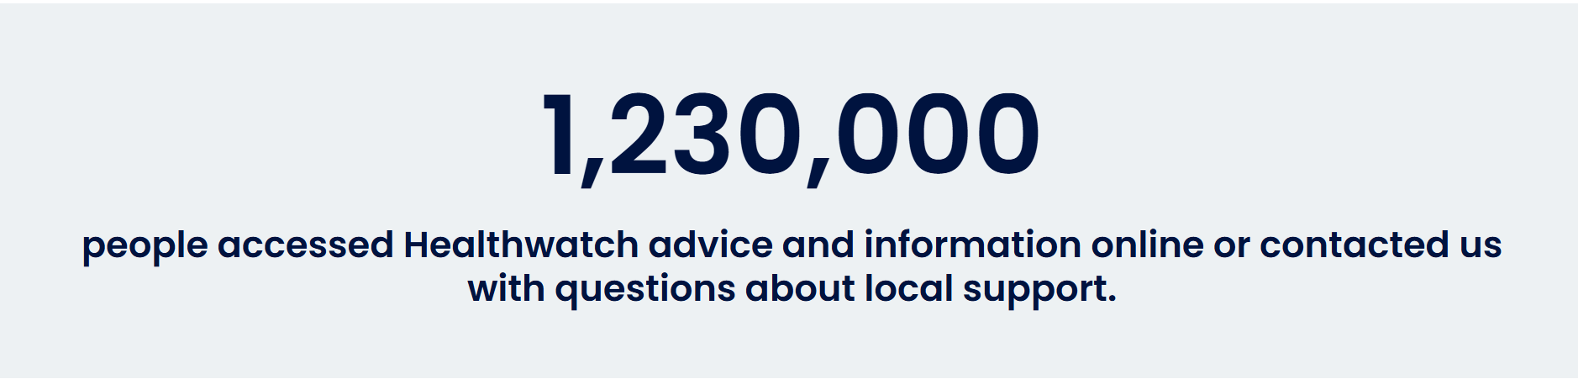

BSL – How Healthwatch help you find the information that you need video - [BSL - How Healthwatch help you find the information that you need.](https://www.youtube.com/watch?v=9-O5yJSlPQ4)

1. **Age UK Rotherham**

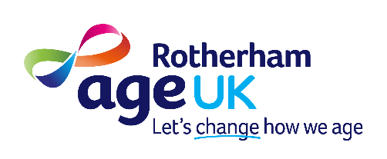Services for older people and their careers in Rotherham <https://www.ageuk.org.uk/rotherham/>

Information & Advice

Age UK Rotherham offers a free and confidential information and advice service for older people, their families and carers.

* Information factsheets and leaflets <https://www.ageuk.org.uk/information-advice/>
* Benefits Entitlement Checks
* Help with form filling and applying for retirement age benefits
* Information about staying warm at home, home adaptations and housing options
* Information about finding a care home or getting some help at home, and how it is funded

email: [info@ageukrotherham.org](mailto:info@ageukrotherham.org) telephone: [01709 835214](tel:+441709835214)

Care & Support Services

Age Uk - Rotherham Engage Image 
- Be Safe
- Be less lonely 
- Stay Independent 
- Be connected 
- Be healthyA Little Bit of Help is a charged for service, providing a helping hand with everyday tasks so you can stay independent for longer.

We provide support, information and assistance to people who use the service and for carers of people who have had a stay in hospital.

Feeling lonely? Our LinkLine telephone service provides a friendly phone call each morning to offer reassurance and support to reduce loneliness and isolation.

email: [csssupport@ageukrotherham.org](mailto:csssupport@ageukrotherham.org) telephone:  [01709 786 955](tel:+441709786955)

Ways to wellbeing in later life

Provides practical support to help people to feel less lonely and reduce social isolation, improve their physical and mental wellbeing, promote creativity and feel more connected within their communities.

EngAge Groups

Improve your Social, Mental & Physical Wellbeing with our social groups led by and for older people in local communities around Rotherham.

e: madeleine.leaper@ageukrotherham.org  
t:  07988 638355

1. Walksafe Poster 
   No more following me home - promoting to download the application.**Community Safety – The Safer Rotherham Partnership**

Safer Neighbourhoods

* 2026 Y6 Harms of Hate event has been set for 3rd February. The Harms of Hate event is an initiative aimed at educating young people about the dangers of hate crime and extremism.

Tackling Violence, Abuse and Exploitation

* SYP have launched a new video campaign 'Don’t Be Exposed' highlighting the dangers of online grooming to teenagers and parents and how easily young people can fall victim to intimate image abuse, sometimes known as revenge porn - being shared widely including with schools and through social media. [https://youtu.be/E0v8ezGyw1g?si=avlqXihk_iWKgHMZ](https://eur02.safelinks.protection.outlook.com/?url=https%3A%2F%2Fyoutu.be%2FE0v8ezGyw1g%3Fsi%3DavlqXihk_iWKgHMZ&data=05%7C02%7CChloe.Slater%40rotherham.gov.uk%7Ce2ef82e8ed024765304708ddcf37dd4d%7C46fbe6fd78ae47699c1dbcea97378af6%7C0%7C0%7C638894561009524700%7CUnknown%7CTWFpbGZsb3d8eyJFbXB0eU1hcGkiOnRydWUsIlYiOiIwLjAuMDAwMCIsIlAiOiJXaW4zMiIsIkFOIjoiTWFpbCIsIldUIjoyfQ%3D%3D%7C0%7C%7C%7C&sdata=%2FVpYA62Csp%2BVcNlobx0PndCzAjEuUpuSAxhpR%2F8rDeM%3D&reserved=0)
* Abuse Has No Age Limit 
  - Hopian Poster (Domestic Abuse Support)Community Safety attended the Global Women’s Voices Network (GWVN) A new initiative funded by the Cohesion Fund and led by South Yorkshire Communities Together. The network brings together women with diverse expertise and lived experience to influence public and statutory services. Its aim is to drive collective action by raising awareness, voicing concerns, and lobbying decision-makers to address growing inequalities.
* Community Safety continues to promote the WalkSafe initiative through social media and other local engagement efforts to support public awareness and safety.
* The Domestic Abuse Summer Campaign returns for the six-week holidays. While summer often brings sunshine and joy, it can also mean a rise in domestic abuse for some. ‘You are not alone — support, safety guidance, and help are always available.’

Find us on social media:

* [www.facebook.com/Rotherhamcommunitysafety](https://eur02.safelinks.protection.outlook.com/?url=http%3A%2F%2Fwww.facebook.com%2FRotherhamcommunitysafety&data=05%7C02%7CChloe.Slater%40rotherham.gov.uk%7C7fa3e73eb39142492e0208ddbfc06745%7C46fbe6fd78ae47699c1dbcea97378af6%7C0%7C0%7C638877555261466970%7CUnknown%7CTWFpbGZsb3d8eyJFbXB0eU1hcGkiOnRydWUsIlYiOiIwLjAuMDAwMCIsIlAiOiJXaW4zMiIsIkFOIjoiTWFpbCIsIldUIjoyfQ%3D%3D%7C0%7C%7C%7C&sdata=kj1ZBSDdVEi5nGpUuFabjL%2BnlbScA2RGUQXqYt9PwA0%3D&reserved=0)
* [www.instagram.com/rmbccommunitysafety](http://www.instagram.com/rmbccommunitysafety)