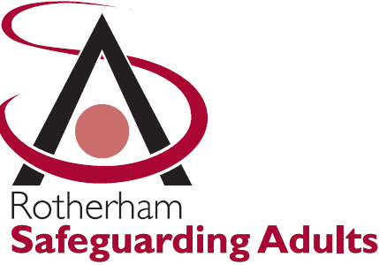
Safeguarding Adults Performance and Quality Sub Group

Terms of Reference

The purpose of the Safeguarding Adults Performance and Quality Sub Group is to provide a joint agency forum for the development and monitoring of all performance related information in relation to Safeguarding Adults policy and practice in response to direction from the Safeguarding Adults Board.

1. Specific Responsibilities

  - Oversee the development of a quarterly Safeguarding Adults performance report including all partner agencies working to safeguard adults at risk from abuse and including :
- Incidence of Abuse; To review a range of information on data by all statutory members as agreed through the dash board data set.
- Interventions; lead agency; multi agency or single agency; average time to completion; decision making meetings; outcomes; conviction; use of IMCA service; use of other advocacy and communications support; proportion with decision making meeting and outcome meeting; distribution of interventions by team;
- User Feedback; results of feedback from users of the safeguarding service; complaints information.
- Commissioning; summary of the general “quality profile” of registered services in Rotherham; summary of position in respect of CQC ratings; placements by rating of home. The inclusion of this information is important because of the proportion of referrals about people receiving registered services, as well as the strong association between provider rating and number of safeguarding referrals.

1.2 Inform the Safeguarding Adult’s Board:
- Provide assurance that vulnerable people were being adequately protected from harm in their area;
- Understand the incidence and pattern of abuse in their locality;
- Be assured as the effectiveness and quality of interventions designed to protect vulnerable people from abuse.
- Provide a summary report form the Group

  - Explore and review information in line with changes in legislation, government policy and local practice experience and advise The Safeguarding Adults Board of the appropriate information. .

  - Establish Task and Finish Groups to undertake specified and required activity and to oversee and review the work of these groups.

  - Carry out annual assessment and peer reviews of partner organisations acting as a critical friend on behalf of the Safeguarding Adult Board.

  - Provide exception reports for the Safeguarding Adults Board

2. Format

2.1 The Assistant Chief Nurse (Vulnerabilities), The Rotherham Foundation Trust chairs the group with an appointed Deputy Chair from any of the other partner agencies.

2.2 Meetings of the Safeguarding Adults Performance and Quality Sub Group will be held bi-monthly. The duration of the meeting will be 2 hours.

2.3 Each statutory member agency should nominate a lead officer and deputy with sufficient authority to speak on the agency’s behalf, feed back and effect necessary changes on issues brought to or arising from the group: for example compliance, policy, practice and training. The voluntary and community sector (VCS) representative will bring a sector perspective on discussions and will report back to the VCS on any actions required by them.

2.4 Each partner agency will contribute agenda items of particular relevance to their agency’s national/local policy issues or experience. Or any other item thought to be relevant to the Safeguarding Adults Performance and Quality Sub Group.

2.5 Terms of Reference for the Safeguarding Adults Performance and Quality Sub Group will be reviewed annually.

3. Safeguarding Adults Performance and Quality Sub Group Membership:

Organisation and Group Remit | Name | Job Title
Chair | June Lovett | Assistant Chief Nurse (Vulnerabilities)
Deputy Chair | Jean Summerfield | Named Nurse Adult Safeguarding
CCG | Rebecca Odell | Adult Safeguarding
SYP | DC Jo Kemp | Agenda and minutes
RMBC | Charna Manterfield | Performance and Quality
RSAB | Jackie Scantlebury | Safeguarding Adult Board Manager
RMBC | Marie Staves | Safeguarding Manager
RMBC | Andrew Wells | Safeguarding HOS
RMBC Commissioning | Jacqui Clark | Manager
RDASH | Charlie Cottom | Nurse Consultant Safeguarding
Voluntary Sector
YAS | Sarah Gallagher | Agenda and minutes
Fire and Rescue Services | Dawn Peat/ Sarah Morton | Safeguarding Officer.

NB: Other partner agencies will be co-opted as appropriate to the Safeguarding Adults Operational Sub Group and the Task and Finish Groups.

Review Date: Oct 2020

